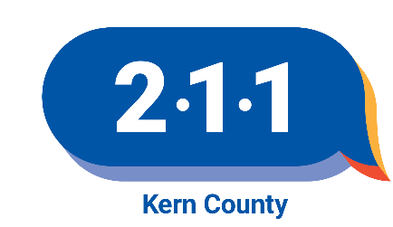

211 Inclusion Criteria

2-1-1 Kern County shall develop, maintain, and/or use an accurate, up-to-date computerized resource database that contains information about the available community resources including detailed data on the services they provide and the conditions under which services are available. The following outlines the criteria for the inclusion or exclusion of agencies and programs in the resource database.

- 2-1-1 Kern County will include the following organizations in its database that have provided services for at least one year and have proof of licensure as required by regulating agencies. Exceptions are made for Emergency Services during disasters.

- Private, non-profit 501 (c) (3) organizations that offer free or low-cost services to the community at large
- Community and self-help support groups. This includes:
  - Self-help support groups that do not charge a fee or charge a nominal fee
  - Advocacy groups and community coalitions
  - Clubs, on a limited basis, concerned with health and human care issues
- Government agencies and government supported groups (no attempt will be made to list all government agencies and departments.)

II. We will consider including the following for-profit and private or group practices:
- For-profit agency services when those services are not adequately met by the non-profit section. Examples include:
  - Programs that satisfy court diversion requirements
  - Programs that provide unique, specifically targeted or difficult to access services such as services for individuals with disabilities, homeless population.
  - Programs that accept Medi-Cal or have a fee structure that meets the needs of low to moderate-income individuals

III. We will not include Agencies that:
- Deny service on the basis of race, sexual orientation, religious belief, or national origin, or that violate federal, state, or local laws or regulations.
- Have been in existence less than one year.
- Do not have an established address, phone, and consistently available contact person.
- Limit their service to members only.
- Engage in fraudulent or illegal activities.
- Misrepresent their services in any way.
- Are not licensed (in areas where licensing standards exist).
- Do not respond when asked to update information.
- Programs where standards of service quality are heavily regulated and for which there exists an entity that adequately maintains current data and provides central referral for the service, e.g. California Nursing Home Search.
- Churches and local groups (Rotary, Jaycees, etc.) that offer no special services to the community at large.
- In general, we will not include private practitioners, group practices of mental providers, medical doctors, podiatrists, dentists, legal/paralegal providers, etc.

IV. Disclaimer

CAPK 2-1-1 Kern County reserves the right to exclude or remove organizations from its resource database. Inclusion in the database does not imply endorsement of an organization or its individual programs or services, nor does omission reflect disapproval. 2-1-1 Kern neither guarantees nor makes any representation as to the accuracy or completeness of the information contained in its resource database. 2-1-1 Kern disclaims any and all responsibility and liability that may be asserted or claimed resulting from or arising out of reliance upon the information and procedures presented in the database. 2-1-1 Kern reserves the right to edit information to meet format, guideline, and space requirements.

