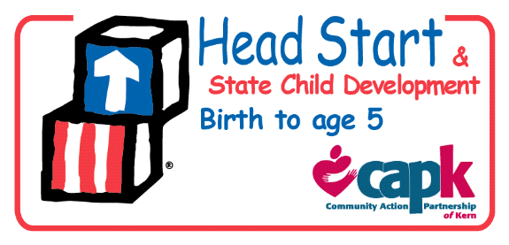
Policy Council
By-Laws Committee Agenda
May 3, 2018
5:30 pm – 6:30 pm

- Call to Order

- Roll Call

- Review proposals for the 2018-2019 Policy Council By-Laws- Janelle Gonzalez, Program Governance Coordinator
- Subcommittee members thoughts/suggestions.
- Adjournment

