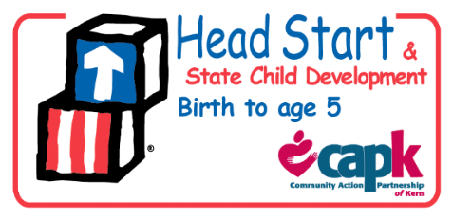

**Policy Council**

**School Readiness Committee Agenda**

**March 14, 2018**

**5:30pm-6:30pm**

1. Call to Order- Chairperson
2. Roll Call/Set Quorum
3. Review of Agenda
4. Preparing families for Kindergarten through Health - Laura Gonzalez, Content Area Specialist-Health
5. Preparing families for Kindergarten through Nutrition - Janey Felsoci, Content Area Specialist- Nutrition
6. Voting for next meeting date
7. Adjournment- Chairperson

**Next meeting to be determined 5:30 pm – 6:30 pm at 5005 Business Park North Suite 130 Board Room**