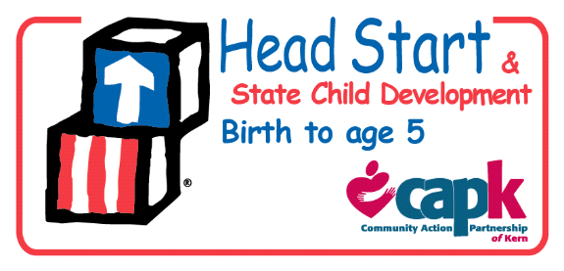
Policy Council
By-Laws Committee Agenda
August 14, 2017
11:30 AM – 12:30 PM

- Call to Order

- Roll Call

- Review changes to the 2017-2018 Policy Council By-Laws
- Adjournment

